# **Time Series Analysis & Visualization in Python**

**What are time series visualization and analytics?**

Time series visualization and analytics empower users to graphically represent time-based data, enabling the identification of trends and the tracking of changes over different periods. This data can be presented through various formats, such as line graphs, gauges, tables, and more.

The utilization of time series visualization and analytics facilitates the extraction of insights from data, enabling the generation of forecasts and a comprehensive understanding of the information at hand. Organizations find substantial value in time series data as it allows them to analyze both real-time and historical metrics.

### **What is Time Series Data?**

Time series data is a sequential arrangement of data points organized in consecutive time order. Time-series analysis consists of methods for analyzing time-series data to extract meaningful insights and other valuable characteristics of the data.

### **Importance of time series analysis**

Time-series data analysis is becoming very important in so many industries, like financial industries, pharmaceuticals, social media companies, web service providers, research, and many more. To understand the time-series data, visualization of the data is essential. In fact, any type of data analysis is not complete without visualizations, because one good visualization can provide meaningful and interesting insights into the data.

### **Basic Time Series Concepts**

* **Trend:** A trend represents the general direction in which a time series is moving over an extended period. It indicates whether the values are increasing, decreasing, or staying relatively constant.
* **Seasonality:** Seasonality refers to recurring patterns or cycles that occur at regular intervals within a time series, often corresponding to specific time units like days, weeks, months, or seasons.
* **Moving average:** The moving average method is a common technique used in time series analysis to smooth out short-term fluctuations and highlight longer-term trends or patterns in the data. It involves calculating the average of a set of consecutive data points, referred to as a “window” or “rolling window,” as it moves through the time series
* **Noise:** Noise, or random fluctuations, represents the irregular and unpredictable components in a time series that do not follow a discernible pattern. It introduces variability that is not attributable to the underlying trend or seasonality.
* **Differencing:** Differencing is used to make the difference in values of a specified interval. By default, it’s one, we can specify different values for plots. It is the most popular method to remove trends in the data.
* **Stationarity:** A stationary time series is one whose statistical properties, such as mean, variance, and autocorrelation, remain constant over time.
* **Order:** The order of differencing refers to the number of times the time series data needs to be differenced to achieve stationarity.
* **Autocorrelation**: Autocorrelation, is a statistical method used in time series analysis to quantify the degree of similarity between a time series and a lagged version of itself.
* **Resampling**: Resampling is a technique in time series analysis that involves changing the frequency of the data observations. It’s often used to transform the data to a different frequency (e.g., from daily to monthly) to reveal patterns or trends more clearly.

### **Types of Time Series Data**

Time series data can be broadly classified into two sections:

**1. Continuous Time Series Data:**Continuous time series data involves measurements or observations that are recorded at regular intervals, forming a seamless and uninterrupted sequence. This type of data is characterized by a continuous range of possible values and is commonly encountered in various domains, including:

* *Temperature Data:* Continuous recordings of temperature at consistent intervals (e.g., hourly or daily measurements).
* *Stock Market Data:* Continuous tracking of stock prices or values throughout trading hours.
* *Sensor Data:* Continuous measurements from sensors capturing variables like pressure, humidity, or air quality.

2. **Discrete Time Series Data:** Discrete time series data, on the other hand, consists of measurements or observations that are limited to specific values or categories. Unlike continuous data, discrete data does not have a continuous range of possible values but instead comprises distinct and separate data points. Common examples include:

* *Count Data:* Tracking the number of occurrences or events within a specific time period.
* *Categorical Data:* Classifying data into distinct categories or classes (e.g., customer segments, product types).
* *Binary Data:* Recording data with only two possible outcomes or states.

### **Visualization Approach for Different Data Types:**

* Plotting data in a **continuous time series** can be effectively represented graphically using line, area, or smooth plots, which offer insights into the dynamic behavior of the trends being studied.
* To show patterns and distributions within discrete time series data, bar charts, histograms, and stacked bar plots are frequently utilized. These methods provide insights into the distribution and frequency of particular occurrences or categories throughout time.

## **Time Series Data Visualization using Python**

We will use Python libraries for visualizing the data. The link for the dataset can be found [here](https://github.com/Neelu-Tiwari/dataset/blob/main/stock_data.csv).

### **Importing the Libraries**

**import** pandas as pd

**import** numpy as np

**import** seaborn as sns

**import** matplotlib.pyplot as plt

**from** statsmodels.graphics.tsaplots **import** plot_acf

**from** statsmodels.tsa.stattools **import** adfuller

### **Loading The Dataset**

# reading the dataset using read_csv

df **=** pd.read_csv("stock_data.csv",

parse_dates**=**True,

index_col**=**"Date")

# displaying the first five rows of dataset

df.head()

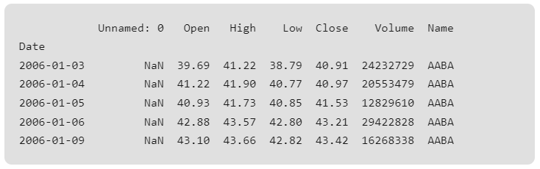

#### **Dropping Unwanted Columns**

# deleting column

df.drop(columns**=**'Unnamed: 0', inplace **=**True)

df.head()

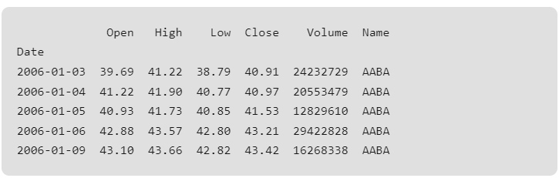

#### **Plotting Line plot for Time Series data:**

# Assuming df is your DataFrame

sns.set(style**=**"whitegrid") # Setting the style to whitegrid for a clean background

plt.figure(figsize**=**(12, 6)) # Setting the figure size

sns.lineplot(data**=**df, x**=**'Date', y**=**'High', label**=**'High Price', color**=**'blue')

# Adding labels and title

plt.xlabel('Date')

plt.ylabel('High')

plt.title('Share Highest Price Over Time')

plt.show()

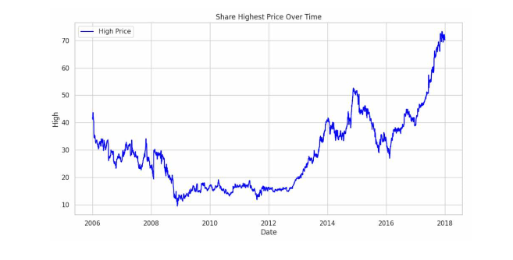

### **Resampling**

To better understand the trend of the data we will use the **resampling method,** resampling the data on a monthly basis can provide a clearer view of trends and patterns, especially when we are dealing with daily data.

# Assuming df is your DataFrame with a datetime index

df_resampled **=** df.resample('M').mean() # Resampling to monthly frequency, using mean as an aggregation function

sns.set(style**=**"whitegrid") # Setting the style to whitegrid for a clean background

# Plotting the 'high' column with seaborn, setting x as the resampled 'Date'

plt.figure(figsize**=**(12, 6)) # Setting the figure size

sns.lineplot(data**=**df_resampled, x**=**df_resampled.index, y**=**'High', label**=**'Month Wise Average High Price', color**=**'blue')

# Adding labels and title

plt.xlabel('Date (Monthly)')

plt.ylabel('High')

plt.title('Monthly Resampling Highest Price Over Time')

plt.show()

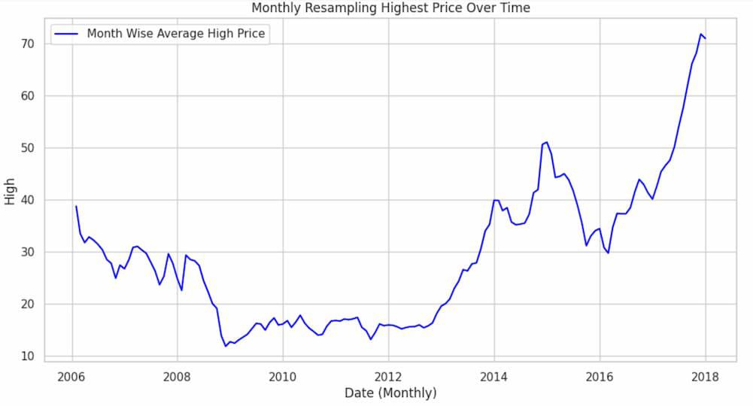

We have observed an upward **trend** in the resampled monthly volume data. An upward trend indicates that, over the monthly intervals, the “high” column tends to increase over time.

### **Detecting Seasonality Using Auto Correlation**

We will detect Seasonality using the autocorrelation function (ACF) plot. Peaks at regular intervals in the ACF plot suggest the presence of seasonality.

# If 'Date' is a column, but not the index, you can set it as the index

df.set_index('Date', inplace**=**True)

# Plot the ACF

plt.figure(figsize**=**(12, 6))

plot_acf(df['Volume'], lags**=**40) # You can adjust the number of lags as needed

plt.xlabel('Lag')

plt.ylabel('Autocorrelation')

plt.title('Autocorrelation Function (ACF) Plot')

plt.show()

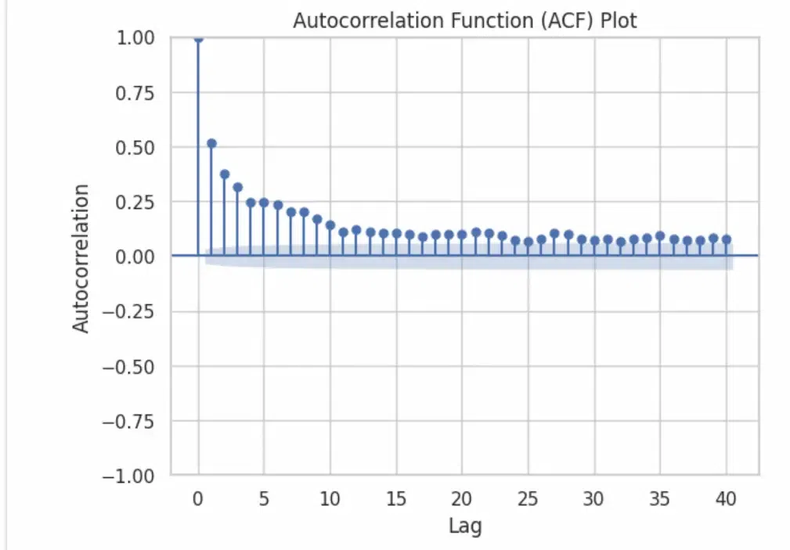

The presence of seasonality is typically indicated by peaks or spikes at regular intervals, as there are none there is no seasonality in our data.

### **Detecting Stationarity**

We will perform the [ADF test](https://www.geeksforgeeks.org/how-to-check-if-time-series-data-is-stationary-with-python/) to formally test for stationarity.

The test is based on the;

* Null hypothesis that a unit root is present in the time series, indicating that the series is non-stationary.
* The alternative hypothesis is that the series is stationary after differencing (i.e., it has no unit root).

The ADF test employs an augmented regression model that includes lagged differences of the series to determine the presence of a unit root.

**from** statsmodels.tsa.stattools **import** adfuller

# Assuming df is your DataFrame

result **=** adfuller(df['High'])

print('ADF Statistic:', result[0])

print('p-value:', result[1])

**print**('Critical Values:', result[4])

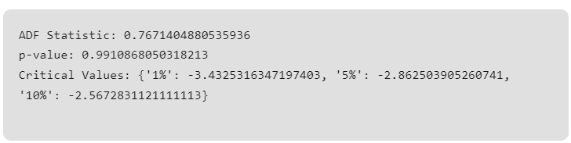

* Based on the ADF Statistici.e > all Critical Values, So, we accept the null hypothesis and conclude that the data does not appear to be stationary according to the Augmented Dickey-Fuller test.
* This suggests that differencing or other transformations may be needed to achieve stationarity before applying certain time series models.

### **Smoothening the data using Differencing and Moving Average**

Differencing involves subtracting the previous observation from the current observation to remove trends or seasonality.

# Differencing

df['high_diff'] **=** df['High'].diff()

# Plotting

plt.figure(figsize**=**(12, 6))

plt.plot(df['High'], label**=**'Original High', color**=**'blue')

plt.plot(df['high_diff'], label**=**'Differenced High', linestyle**=**'--', color**=**'green')

plt.legend()

plt.title('Original vs Differenced High')

plt.show()

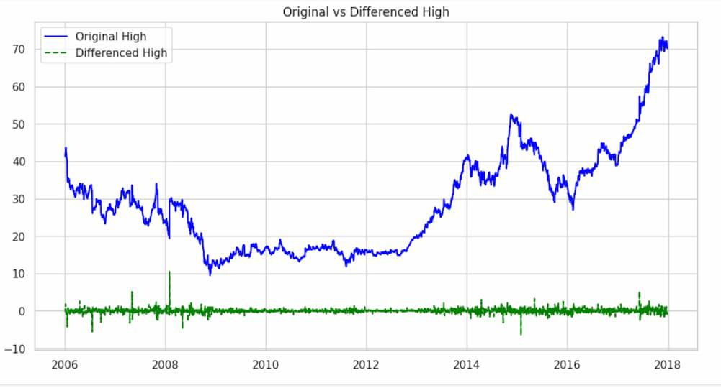

The df['High'].diff() part calculates the difference between consecutive values in the ‘High’ column. This differencing operation is commonly used to transform a time series into a new series that represents the changes between consecutive observations.

# Moving Average

window_size **=** 120

df['high_smoothed'] **=** df['High'].rolling(window**=**window_size).mean()

# Plotting

plt.figure(figsize**=**(12, 6))

plt.plot(df['High'], label**=**'Original High', color**=**'blue')

plt.plot(df['high_smoothed'], label**=**f'Moving Average (Window={window_size})', linestyle**=**'--', color**=**'orange')

plt.xlabel('Date')

plt.ylabel('High')

plt.title('Original vs Moving Average')

plt.legend()

plt.show()

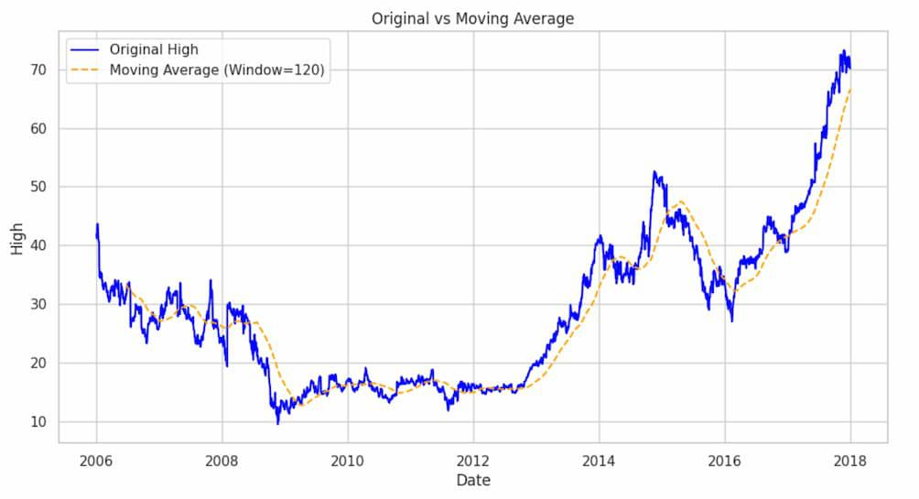

This calculates the moving average of the ‘High’ column with a window size of 120(A quarter) , creating a smoother curve in the ‘high_smoothed’ series. The plot compares the original ‘High’ values with the smoothed version.Now let’s plot all other columns using a subplot.

### **Original Data Vs Differenced Data**

Printing the original and differenced data side by side we get;

# Create a DataFrame with 'high' and 'high_diff' columns side by side

df_combined **=** pd.concat([df['High'], df['high_diff']], axis**=**1)

# Display the combined DataFrame

print(df_combined.head())

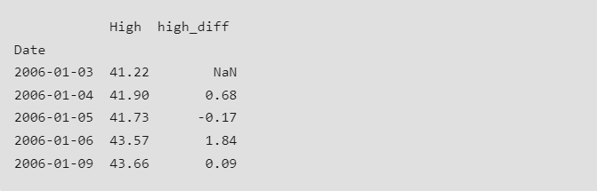

Hence, the ‘high_diff’ column represents the differences between consecutive high values .The first value of ‘high_diff’ is NaN because there is no previous value to calculate the difference.

As, there is a NaN value we will drop that proceed with our test,

# Remove rows with missing values

df.dropna(subset**=**['high_diff'], inplace**=**True)

df['high_diff'].head()

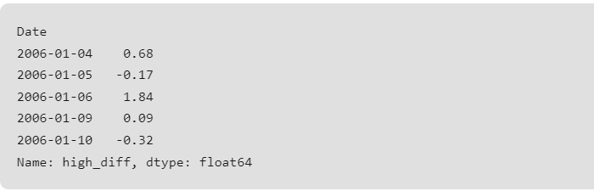

**from** statsmodels.tsa.stattools **import** adfuller

# Assuming df is your DataFrame

result **=** adfuller(df['high_diff'])

print('ADF Statistic:', result[0])

print('p-value:', result[1])

**print**('Critical Values:', result[4])

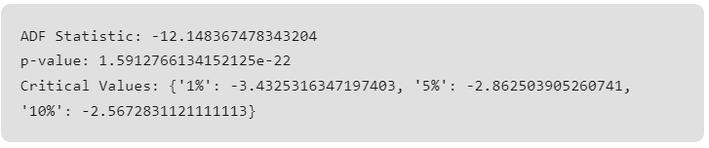

* Based on the ADF Statistici.e < all Critical Values, So, we reject the null hypothesis and conclude that we have enough evidence to reject the null hypothesis. The data appear to be stationary according to the Augmented Dickey-Fuller test.
* This suggests that differencing or other transformations may be needed to achieve stationarity before applying certain time series models.